Guide to setting up membership.
- Go to BHS website (www.bhs.org.uk)

- Scroll across the top banner to “Brtish Riding Clubs”

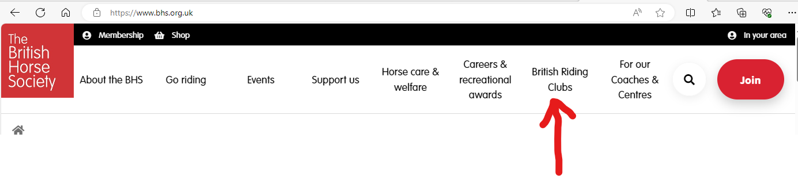
- Click drop down arrow & it will take you to “Membership & Clubs”: -

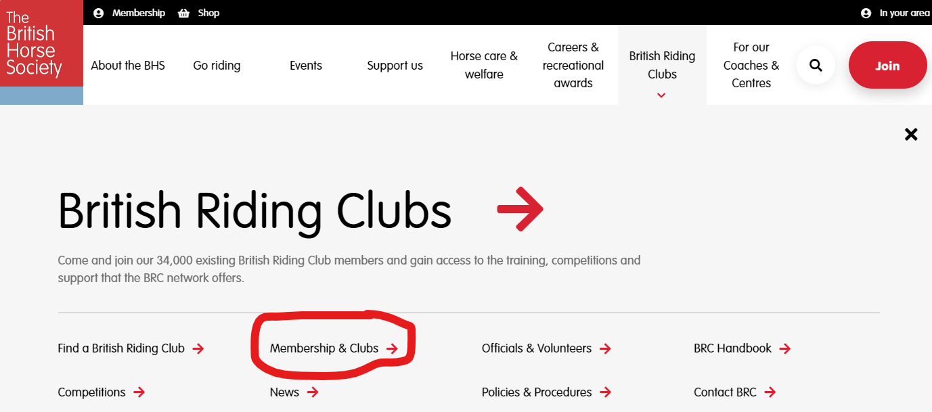

- Select membership & Clubs, which will take you to joining information: -

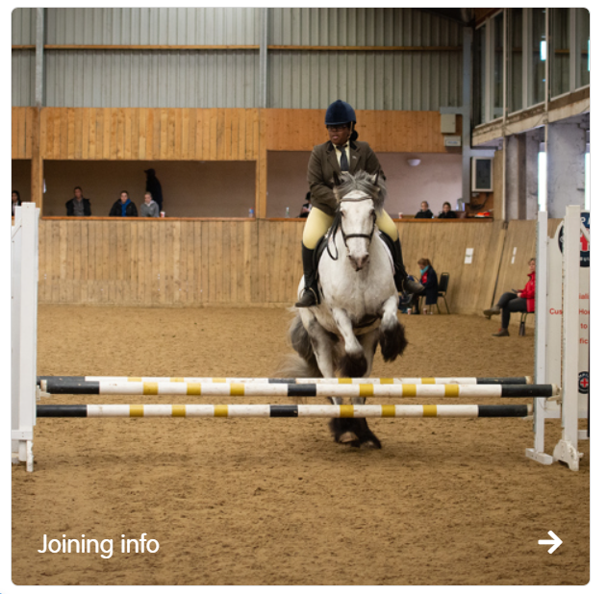

- Scroll to the very bottom of the page & click “Find a club”: -
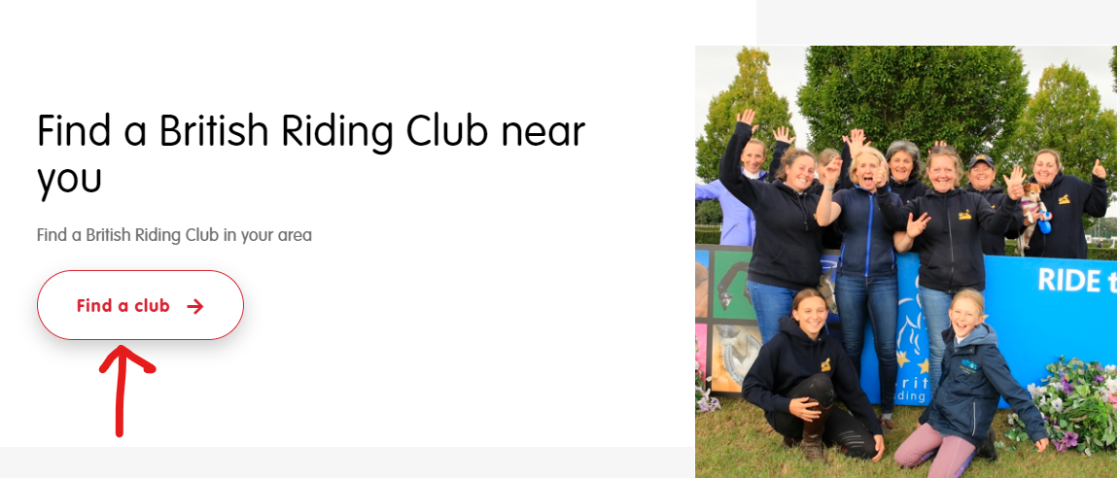

- You have 2 options you can either use your location & go through all clubs in your area (which didn’t work for me – I am in NR9 & selected a 50 mile radius & it did not bring up Carleton Riding Club - I will raise this with BRC) or you can scroll to the bottom of the page (all clubs are in alphabetical order) keep “Loading more” until you see “Carleton Riding Club”

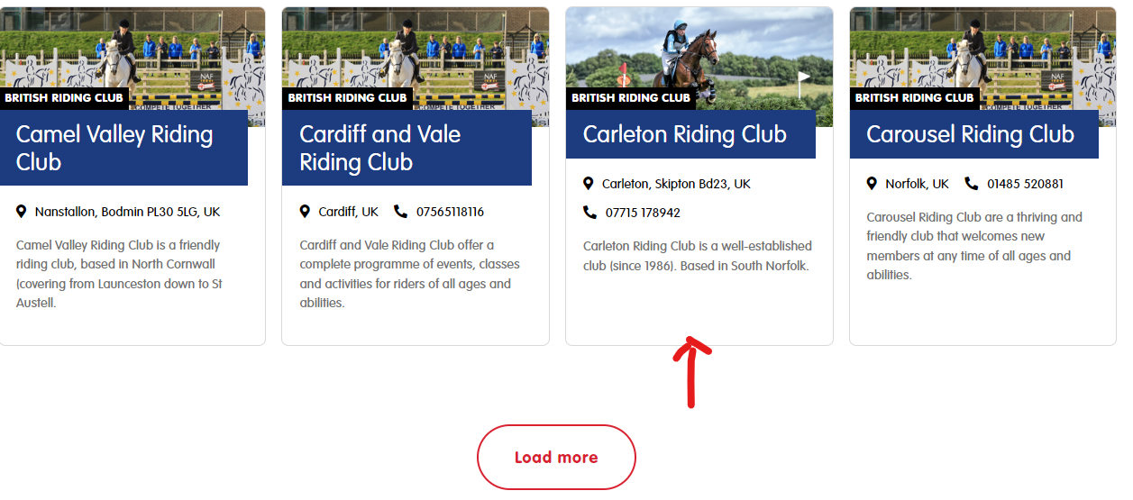
- Click “Carleton Riding Club” (Please ignore location details further down the page as these are incorrect)

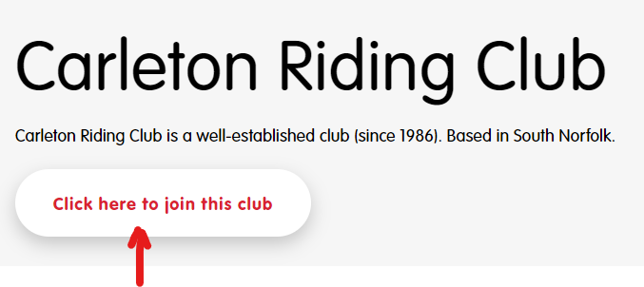
- Click “Click here to join this club”: -

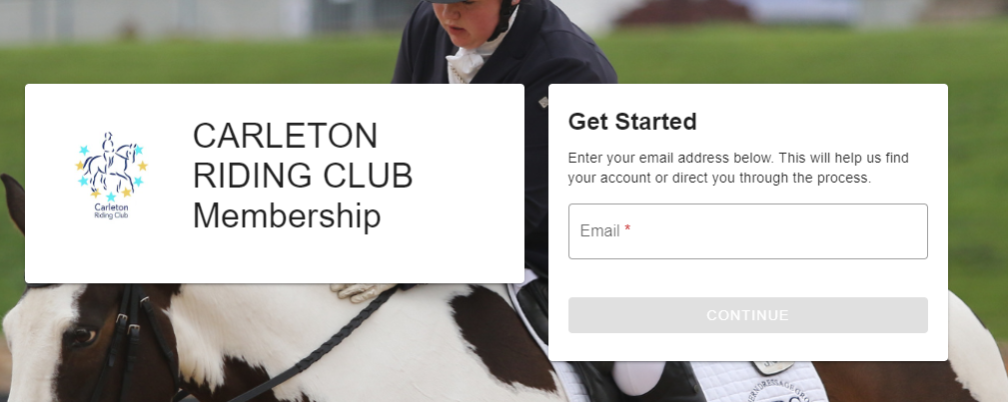

- Enter your email address

- If you are a new member, it will ask you to set up a password, if an existing member it will take you to your profile, click select profile: -
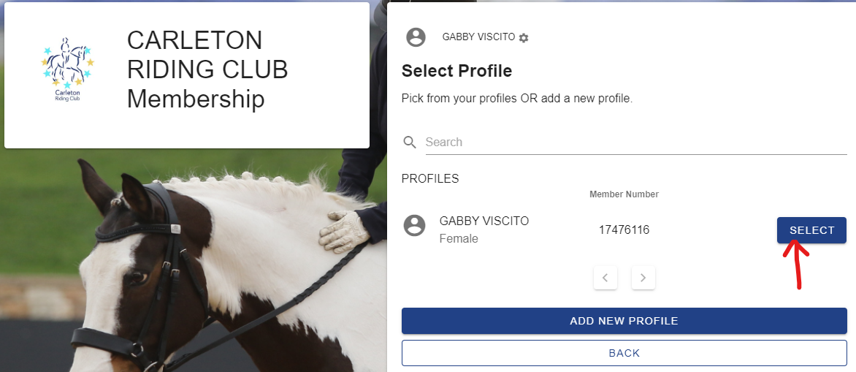
- I have already joined for 2024 so this is what I see, I am a current member of the committee & the club, I have set up an auto renewal for my membership which is due to expire 31/12/2024. To the left of the page is where you set up your personal details, contact details, address etc.
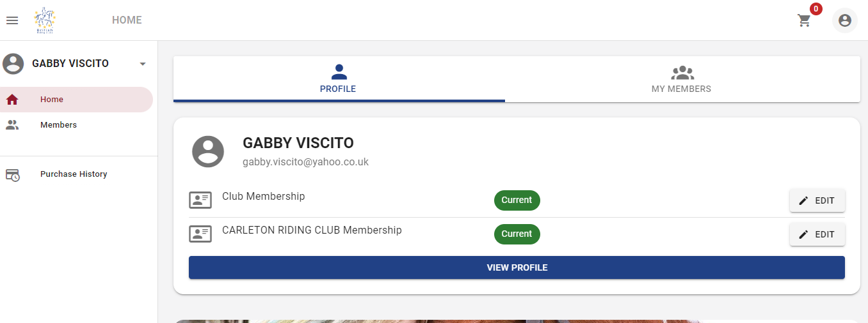
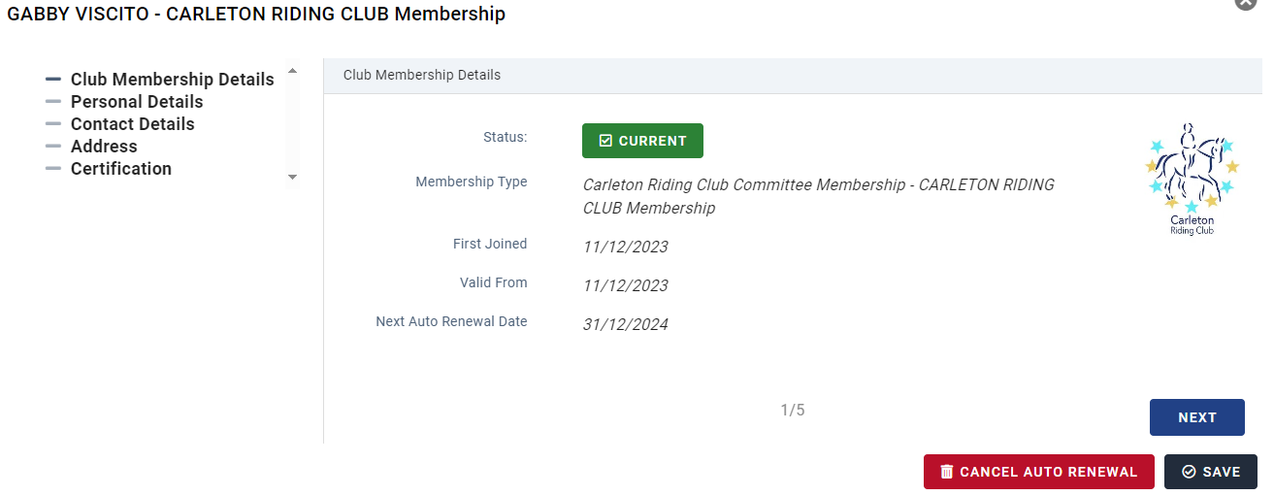
- Whether a new member or an existing member once you are in the site you will be able to amend your personal details, agree to terms and conditions etc. You will be able to renew and pay for your club membership.
Please find below some user guides that will help you.
How to update your personal details
https://britishridingclubs.sport80.com/uploads/how_to_update_your_personal_details-2023-11-24.pdf
Registering as a new member.
https://britishridingclubs.sport80.com/uploads/registering_as_a_new_member-2023-11-23.pdf
Registering an existing BRC member
https://britishridingclubs.sport80.com/uploads/registering_an_existing_brc_member-2023-11-23.pdf
Adding another member to your account
https://britishridingclubs.sport80.com/uploads/adding_another_member_to_your_account-2023-11-23.pdf
If you have any queries, please reach out to me.
Kind regards
Gabby

